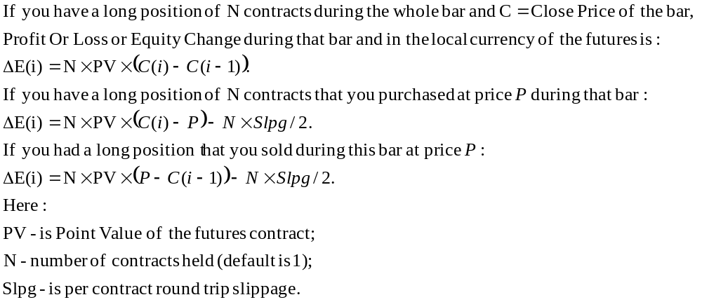
You can do the mirror image changes to get the similar formulas for the shorts.

